Gamma News – Unfolding Here 1
May 2024

Announcement:
Planning Meeting We decided on May 25th at 11:00 at my house.
5209 Cutty Way
702-494-7525

Some reminders:
Our visit to the Queen of Hearts is 5/4/24 @11 am
Located in: Sunset Ridge Plaza
Address: 2895 N Green Valley Pkwy Suite D, Henderson, NV 89014
Phone: (702) 769-8187

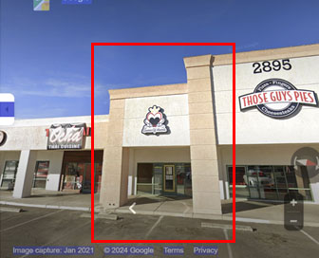

Dues are Due! You can give them to Judy at the Tea in May. You can also mail her the check for active. Dues are still $80 for Active and $30 for Reserve. Checks should be made out to Gamma Chapter-DKG.

